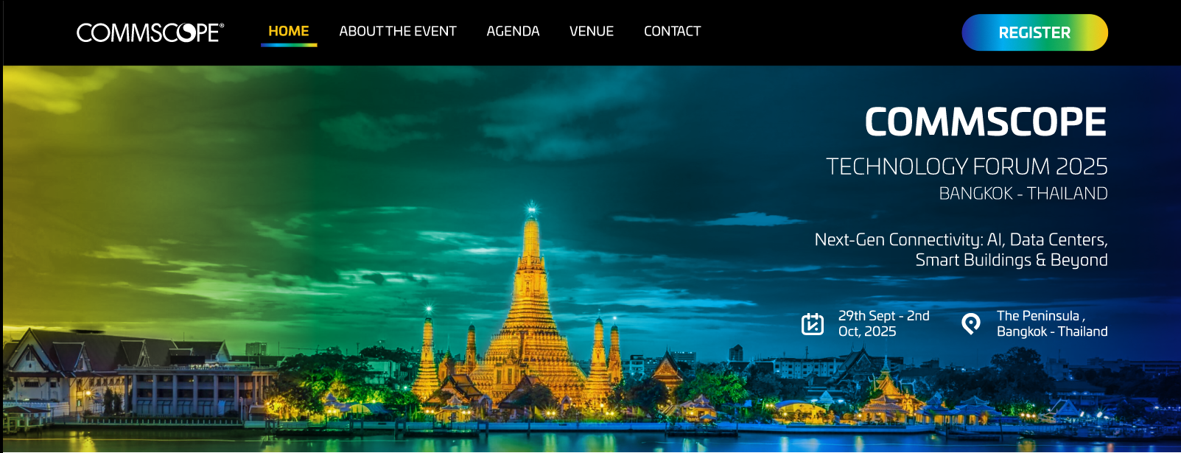

**Dear Valued Customer,**

On behalf of the CommScope team, we are delighted to invite you to the **CommScope Technology Forum 2025**, taking place from **29 September to 2 October 2025** at the **Peninsula Hotel, Bangkok, Thailand**.

This year’s forum, themed ***Next-Gen Connectivity: AI, Data Centres, Smart Buildings & Beyond***, will explore how next-generation infrastructure is transforming industries globally—and how CommScope is at the forefront of this evolution.

Join industry leaders, innovators, and technology experts for an immersive experience in one of Asia’s most vibrant cities. Gain insights into:

* AI-powered infrastructure
* Future-ready data centres
* Smart building technologies
* Emerging innovations in edge computing, 5G, IoT, and more

We look forward to welcoming you to Bangkok for a dynamic event filled with knowledge sharing, strategic dialogue, and meaningful networking.

**See you at the CommScope Technology Forum 2025!**

Best regards,  
**The CommScope Team**

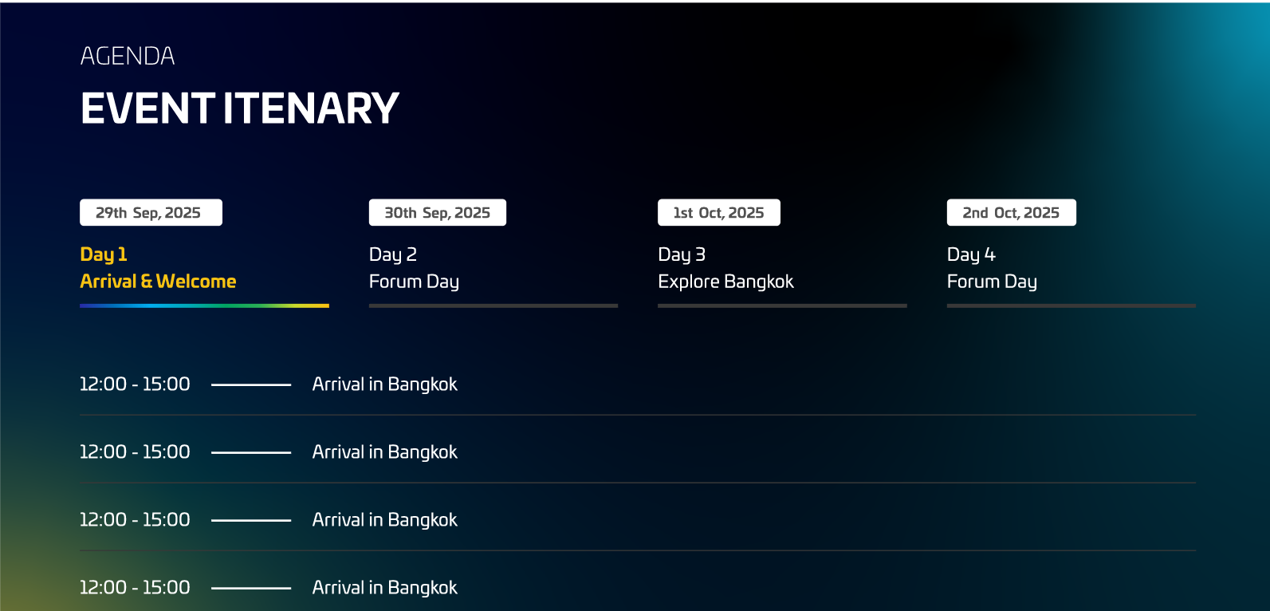

Dinner

Arrival & Check-in

**AGENDA**



**AGENDA**

Evening Dinner Cruise

Full Day Conference



Lunch at the restaurant

**AGENDA**

Grand Palace Tour



Check out & Departure

**AGENDA**

Breakfast



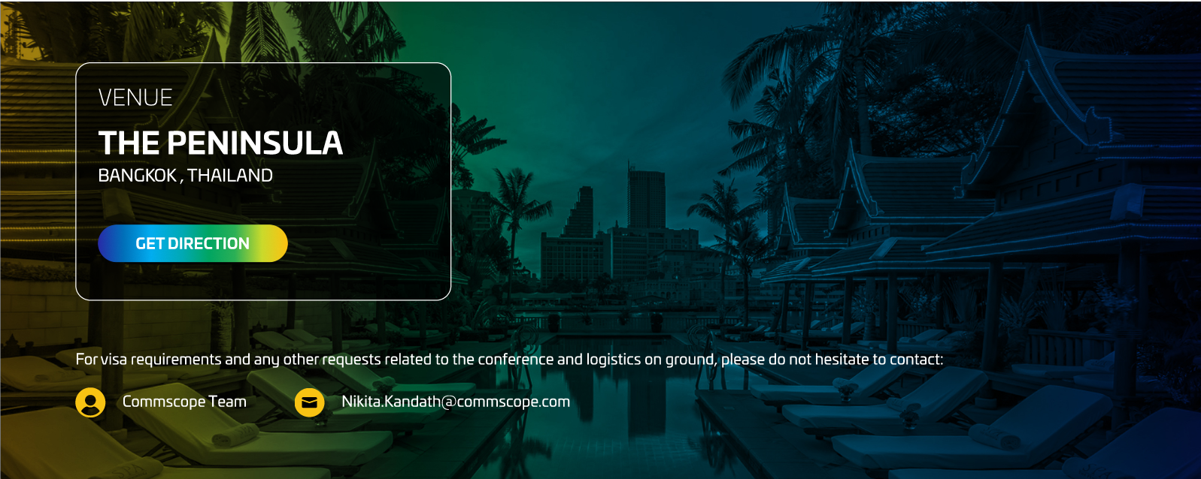

For information on visa eligibility and related details, please **click here!**

Single man icon. People icon. User profile symbol. Person ...Email Icon Images – Browse 1,119,377 Stock Photos, Vectors ...

E-mail: MEAMarketing@commscope.com

CommScope Team

For any other requests related to the conference and logistics on ground, please do not hesitate to contact:

CORRECTIONS

1. Gradients in the buttons ‘Register’ and ‘Get Direction’ are wrong – reverse it
2.  - check spelling between About & The
3. Add a Register button between Agenda & Venue sections